Booking a Reservation Online Using a Group Code

- Go to https://www.chinookwindscasino.com/lodging/ and click the book now link.
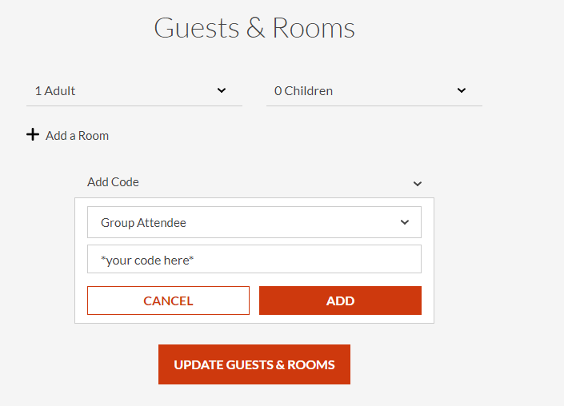
- You will then be presented with the following screen. Please set the number of adults and children that will be accompanying you and enter your block code in the designated area the click “add”.
- This will take you to the block information screen showing available check in dates, the check out dates, and the block cutoff date.

Your Block Code Is:
052024NWJF
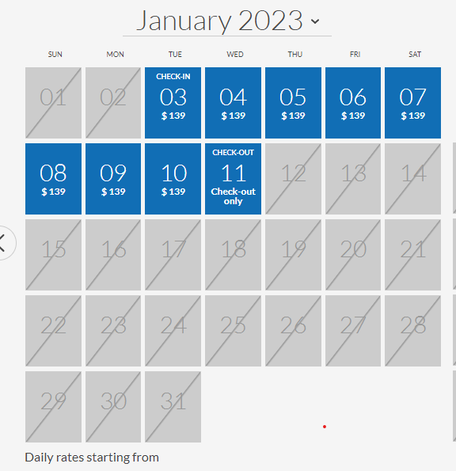
- If your block information is accurate, please proceed to the next step.

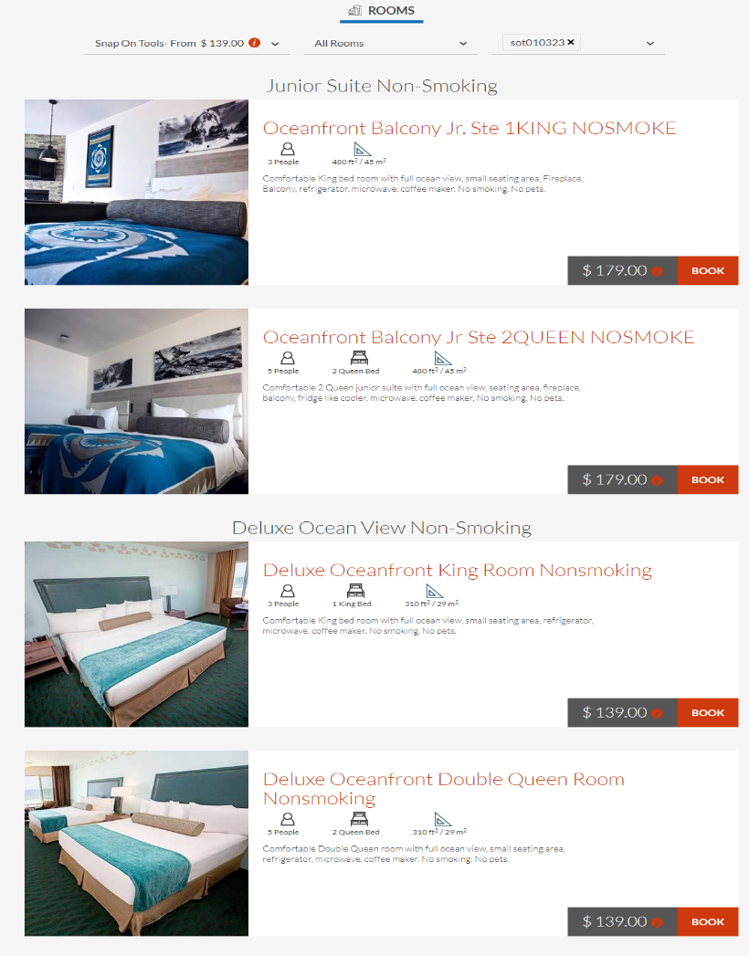
- The following step shows the dates that are available within the block, notice that dates outside of the block are grayed out and not accessible at this time.
- After selecting the dates, please continue to the next screen. At this point it will show the prices, rooms, and a brief description of what is available in your block.
- Choose the room you would like for your stay and click “book”.
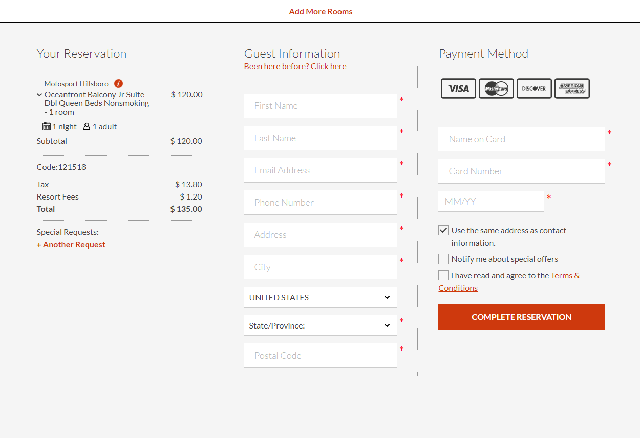
- Fill in the necessary information and click “complete reservation” to finalize your reservation and get your confirmation email. At this point you have officially booked your reservation.

- If you have any issues or questions when booking please call 1-888-CHINOOK to speak with a representative.

- Thank you for choosing Chinook Winds. We hope you enjoy your time with us here on the beautiful Oregon Coast.

